
International University of Sarajevo
Faculty of Engineering and Natural Sciences

Computer Architecture
CS304 Spring 2025

PROJECT 1 REPORT
Matrices Operations

Professor: dr. Ali Almisreb

Students: Berina Juković 230302282
Hena Šehović 230302146
Berin Žunić 230302280

Sarajevo, 09.04.2024.
Contents
1. Introduction 3
2. The Project 5
2.1. MIPS Commands used 5
2.2. Program Architecture 6
2.2.1. Data Segment Organization 6
2.2.2. Input Functiom 8
2.2.3. Display Matrix 13
2.2.4. Print Matrix 16
2.2.5. Add Matrices 17
2.2.6 Subtract Matrices 19
2.2.7 Multiplication of matrices 20
3. Conclusion 24
4. Resources 24
5. List of Figures 24

Introduction

This project shows the use of fundamental matrix operations with assembly language programming, demonstrating low-level implementation of mathematical operations encapsulated in high-level languages. Highlighting computer architecture principles, we have designed effective assembly procedures to perform matrix addition, subtraction, and multplication.
Implementation emphasizes:
- Direct register and memory manipulation to achieve highest performance
- Optimization of use of processor facilities like parallel operations
- Effective control of the memory hierarchy (registers, cache, RAM)
- Optimization techniques specific to assembly programming

Our solution provides an overview of how modern processors execute arithmetic operations in the hardware and the architectural design issues related to handling two-dimensional data structures. Our project is a real-world examination of the conection between algorithmic design, instruction set architecture, and actual
hardware implementation.

This example shows how assembly language provides fine control over computational resources while highlighting the challenges of managing complex data structures at this abstraction level. The program is interactive, as it allows users to input matrices, execute operations, and display results while ensuring proper error handling for dimension mismatches. The following figures visually show how a matrix looks and what the program does.

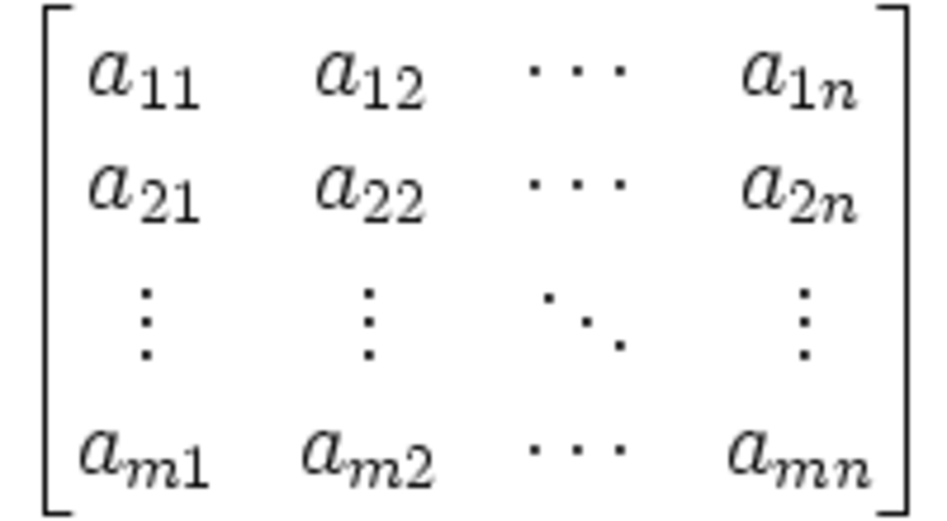
Picture 1: Matrix notation
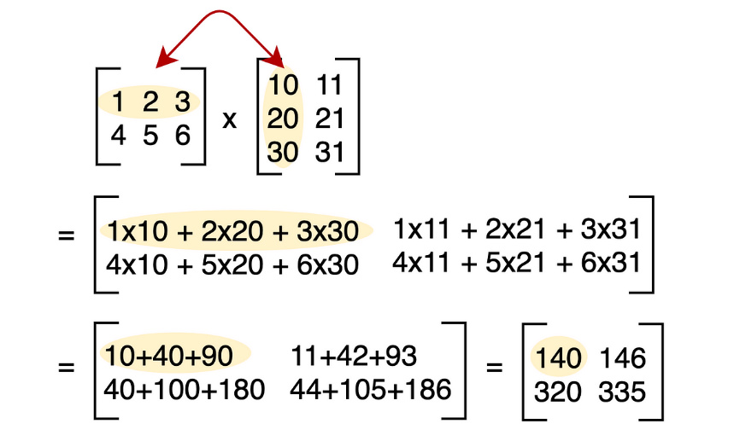
Picture 2: How matrices multiplacation works

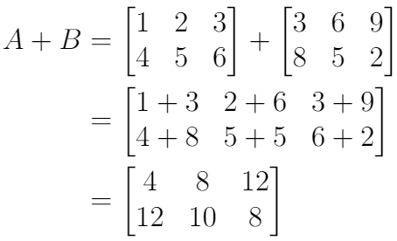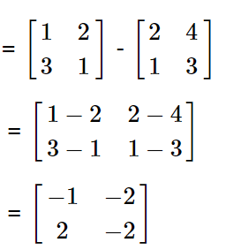
Pictures 3 and 4: Matrices summation and subtraction

The Project

MIPS Commands used
This part of the reports aims to explain and list the commands used in creating this project, the commands are dividied based on their purpose.
- Data Declaration Commands
.space N -Reserves N bytes of uninitialized memory
.word val -Stores a 32-bit integer value
.asciiz "str"-Stores a null-terminated string

- Arithmetic/Logical Operations
add rd, rs, rt-Adds two registers (rd = rs + rt)
sub rd, rs, rt-Subtracts (rd = rs - rt)
mul rd, rs, rt-Multiplies (rd = rs * rt)

- Memory Access Commands
lw rt, offset(base)-Loads a word from memory
sw rt, offset(base)-Stores a word to memory
la rd, label-Loads address of a label

- Control Flow Commands
j label-Unconditional jump
beq rs, rt, label-Branches if rs == rt
bne rs, rt, label-Branches if rs != rt
jal label-Jumps and saves return address in $ra
jr rs-Jumps to address in register

- System Calls (Syscalls)
li $v0, 1-Prepares to print integer
li $v0, 4-Prepares to print string
li $v0, 5-Reads integer input
li $v0, 10-Terminates program
syscall-Executes the prepared syscall

- Register Usage Conventions
$s0-$s7-Saved variables (preserved across calls)
$t0-$t9-Temporary registers
$a0-$a3-Argument passing
$v0-$v1-Return values
$ra-Return address

2.2. Program Architecture

2.2.1. Data Segment Organization
In this part we declare variables and reserve memory or initialize all necessery variables
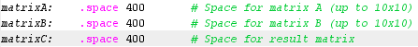
Picture 5: Declaring variables and reserve bytes in memory
In this part use .space 400 to reserve 400 bytes of memory for each matrix. The reason is each 32-bit integer requires 4 bit and we want to have matrices up to 10x10 dimensions and with simple math we can conclude that ieach matrix requires 400 bytes of memory.

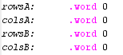
Picture 6: Storing values

With command .word We store a 32-bit integer values for rows and columns of matrices A and B, the reason is to prevents operations on uninitialized matrices.

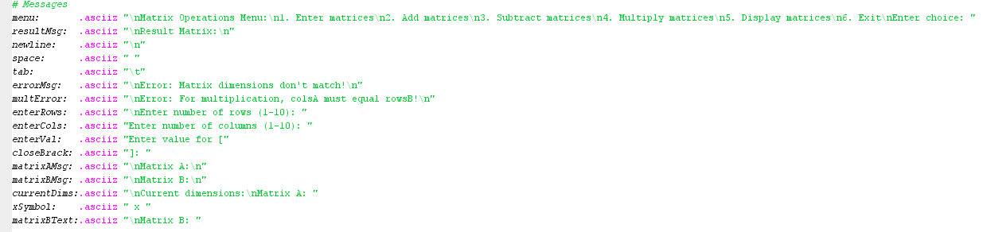
Picture 7: Messages
Also create a lot of variables as messages to make easier code for read and write. We used .asciiz to store a null-terminated string

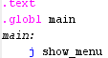
Picture 8: Text segment and main function
At this part we start with our code and in the main function we see jump to show_menu function.

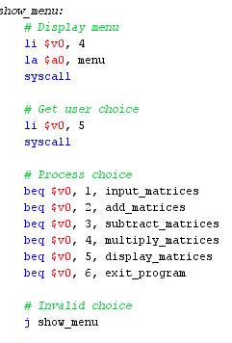
Picture 9: Function show_menu
As you can see this function display the menu, get user choice and process choice.

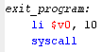
Picture 10: Function exit_program
This function just stop the execution of the code.
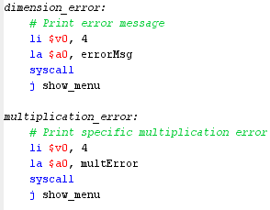
Picture 11: Functions dimension_error and multiplication_error
In these two functions the only purpose is to print the message(error) and jump in show_menu function.

2.2.2. Input Functiom
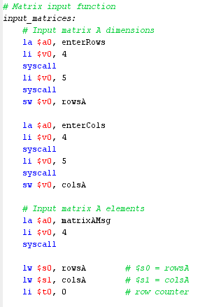
Picture 12: Input matrix for matrix A (Part 1)
First we start with inputs for matrix A and the first step is to input the dimension. So program will print the message then take the value and store them. This procedure will execute two times, for row and column. After that program will print the ''matrixAMsg'' and load value to registers to make preparation for loop.
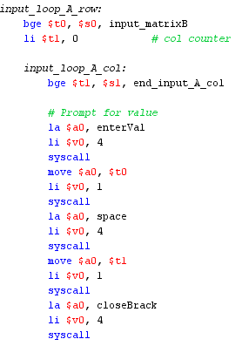
Picture 13: : Input matrix for matrix A (Part 2)
So the first thing in loop is to check is number of row and counter of row are the same, if it is then program will go to function input_matrixB else then it continue with filling the matrix. The next step to set column counter to 0 and then enter the second loop.
In this loop the first thing is to check is number of column and counter of column are the same if it is then jump to end_input_A_col else then prompt the value. As you can see program will first print the message ''enterVal'', copy row index to argument and print that argument, then print the space, do the same for column as do for row and then print closeBrack. As result we have this:
Picture 14: Result after code execution
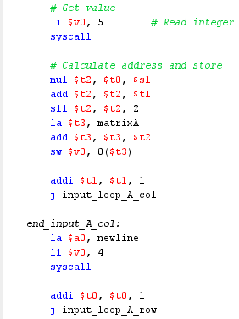
Picture 15: Input matrix for matrix A (Part 3)

So, when we print this beatiful message, now is time to get the value and store. So first thing we get the value that we enter then according to this addressing formula we store the values: $t2=(row * cols + col) * 4 and this is the first three line of that part of code then we load base address add offset to base and stoer the value. Then we increment column counter and repeat inner loop.
When number of column and counter of column are equal then we start with function end_input_A_col. In this function we print newline, then increment counter of row and jump to function input_loop_A_row. This procedure will repate until number of row and counter of row are equal then we go to function input_matrixB.
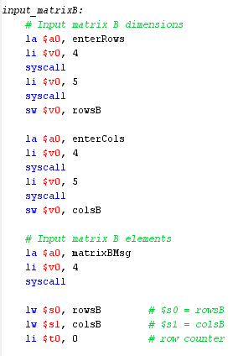
Picture 16: Input matrix for matrix B (Part 1)
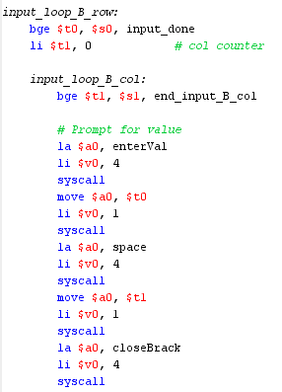
Picture 17: Input matrix for matrix B (Part 2)
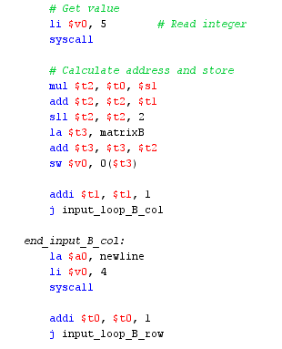
Picture 18: Input matrix for matrix B (Part 3)
The function input_matrixB. are similar, but only difference is at first condition where if number of row and counter of row are the same then program will jump to function input_done.

The purpose of function input_done is to print one beatiful message
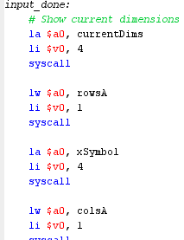
Picture 19: Function input_done (Part 1)
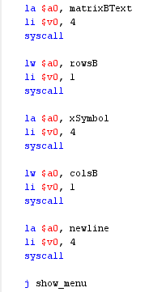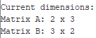
Pictures 20 and 21: Function input_done (Part 2) and result after code execution

2.2.3. Display Matrix
In this part we going to explain how works display_matrices function
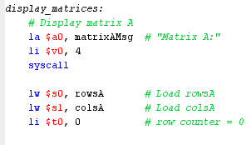
Picture 22: Display matrix A (Part 1)
We first start with displaying Matrix A, so we will print matrixAMsg, then load the values of row and column and set row counter to 0.
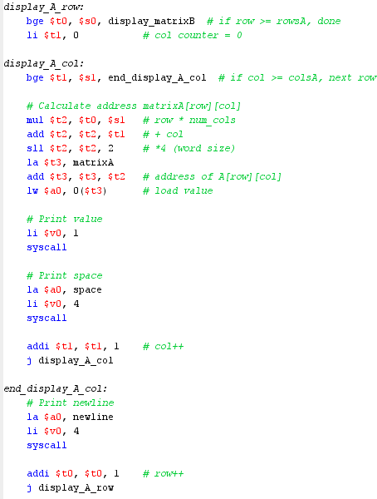
Picture 23: Display matrix A (Part 2)

If you pay attention you can see that procedure for input matrices and display matrices are the same, only difference is that we want now to display the value. Also the same procedure is for B matrix
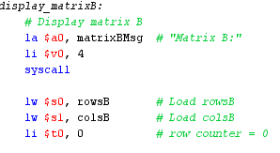
Picture 24: Display matrix B (Part 1)
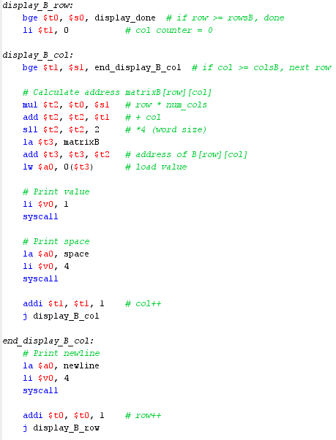
Pictures 25 and 26: Display matrix B (Part 2) and function display_done
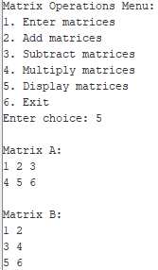
Picture 27: Demonstration of displaying matrices

2.2.4. Print Matrix
This function is the same as previous, so we just show the code, but procedure are the same
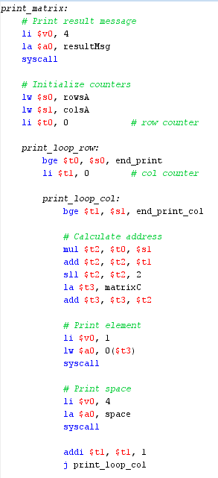 Picture 28: Function print_matrix (Part 1)

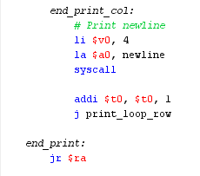
Picture 29: Function print_matrix (Part 2)

2.2.5. Add Matrices
In this part we are going to talk about addition between two matrices
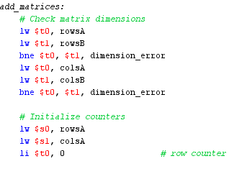
Picture 30: Function add_matrices (Part 1)
First, we check the dimension of matrices, so first we load number of column of both matrices then compare. If there are equal, program will continue, if not then program will jump to dimension_error function. The same is for columns. After program check number of columns and rows, we load values for number of columns and rows of A matrix and set row counter to 0.
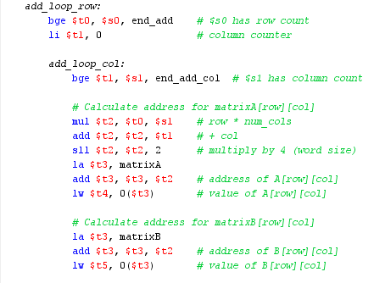
Picture 31: Function add_matrices (Part 2)
Now, we will iterate through matrix. First we check number of row and row counter, if it is equal we jump to end_add function, if not then program will set column counter to 0 and enter to add_loop_col where we check number of column and column counter. If are equal, then program jump to end_add_col function, if not, then program will continue with execution. So first thing we get the value that we enter then according to this addressing formula we store the values: $t2=(row * cols + col) * 4 and this is the first three line of that part of code then we load base address add offset to base and store the value. Next, we repeat procedure for matrix B.

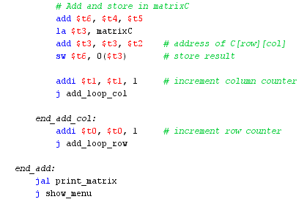
Picture 32: Function add_matrices (Part 3)
The value that we stored from A and B matrix, we add and store to matrix C, then increment the column counter and repeat until the number of column and column counter are equal, then we repeat for rows and when we do all iterations we jump to print_matrix function to display matrix C. After this function program jump to show_menu function.

2.2.6 Subtract Matrices
Subtraction is the same procedure as addition, only exception is part when we add(in this case subtract) two numbers.
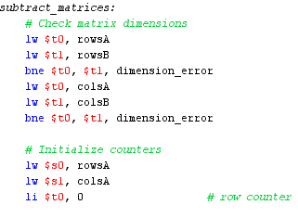
Picture 33: Function subtract_matrices (Part 1)

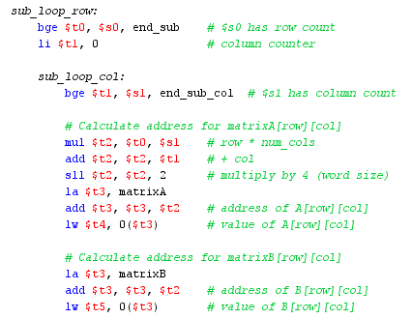
Picture 34: Function subtract_matrices (Part 2)
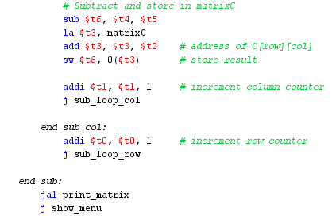
Picture 35: Function subtract_matrices (Part 3)

2.2.7 Multiplication of matrices
So, as for addition/subtraction we check is possible to do a operation, then we we start with procedure.
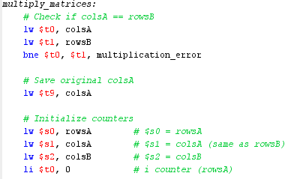
Picture 36: Function mulitplay_matrices (Part 1)
So to check is multiplication possible, we have to check is number of column of matrix A and number of row of matrix B are equal. After that we save the original number of column of matrix A and load number of rows and columns of matrix A and number of column of matrix B and set counter for rows of matrix A to 0.
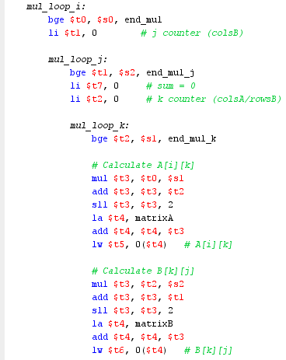
Picture 37: Function mulitplay_matrices (Part 2)

So first we check number of rows of matrix A is equal to counter of rows of matrix A. If it is, we jump to end_mul function. If not, then we continue. Next step is to set another j counter to 0 then enter to antoher loop mul_loop_j . In this loop we again check number of columns of matrix B and j counter. If it is equal then jump to end_mup_j function. If is not, then set sum to 0 and k counter to 0. Then we enter through mul_loop_k function where we check is k counter equal to number of column of matrix A. If it is, program will jump to end_mul_k function. If not, then program will continue. So first thing we get the value that we enter then according to this addressing formula we store the values: $t2=(row * cols + col) * 4 and this is the first three line of that part of code then we load base address add offset to base and store the value. The same thing we will do with matrix B.
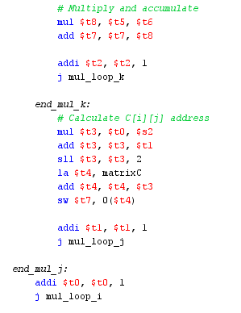
Picture 38: Function mulitplay_matrices (Part 3)

So, we multiply values from matrix A and B then add to sum, increment counter k and repeat this process after counter k and number of column of matrix A are equal. Then we in end_mul_k the value sum will store to Matrix C and increment counter j, program will repeat all before until the counter j is eqaul to number of column of matrix B. In the end_mul_j function we just increment counter i until counter i is equal to number of rows of matrix A, then program jump to end_mul function

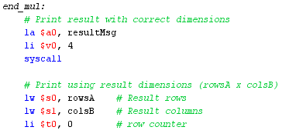
Picture 39: Function mulitplay_matrices (Part 4)

When we fill matrix C then we display the result. The next code is the same as function display_matrices, just name of functions are different. So we do not explain more.
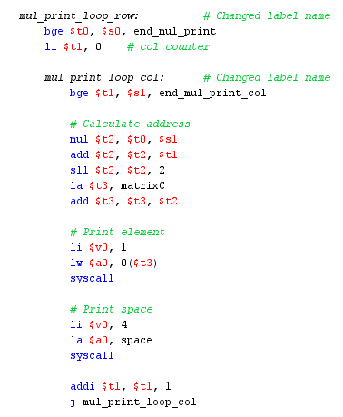
Picture 39: Function mulitplay_matrices (Part 5)

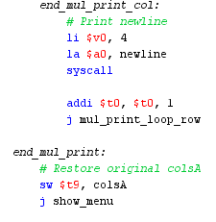
Picture 40: Function mulitplay_matrices (Part 6)

Conclusion
For this assignment, we made an assembly language program capable of performing basic matrix operations, showing how low-level programming can be employed in performing mathematical computations. The program successfully performed addition, subtraction, and multiplication operations on matrices of predefined dimensions, demonstrating assembly's potential in handling complex data structures. However, there lies room for imporoevement. The interface can be made more intuitive and user-friendly, and the current implementation can be made better by enabling dynamic matrices of any size rather than fixed dimensions. This would make the program more flexible, efficient, and handy for more general applications.

Resources
MARS MIPS simulator
https://www.java.com/en/download/
Programmed Introduction to MIPS Assembly Language
https://youtube.com/playlist?list=PLylNWPMX1lPlmEeeMdbEFQo20eHAJL8hx&si=QpbKRQ-aB6XYnqIB
https://youtube.com/playlist?list=PL5b07qlmA3P6zUdDf-o97ddfpvPFuNa5A&si=PcfzoK58R_wbKiZt
https://chatgpt.com/
https://www.deepseek.com/

List of Figures
Picture 1: Matrix notation
Picture 2: How matrices multiplacation works
Pictures 3 and 4: Matrices summation and subtraction
Picture 5: Declaring variables and reserve bytes in memory
Picture 6: Storing values
Picture 7: Messages
Picture 8: Text segment and main function
Picture 9: Function show_menu
Picture 10: Function exit_program
Picture 11: Functions dimension_error and multiplication_error
Picture 12: Input matrix for matrix A (Part 1)
Picture 13: Input matrix for matrix A (Part 2)
Picture 14: Result after code execution
Picture 15: Input matrix for matrix A (Part 3)
Picture 16: Input matrix for matrix B (Part 1)
Picture 17: Input matrix for matrix B (Part 2)
Picture 18: Input matrix for matrix B (Part 3)
Picture 19: Function input_done (Part 2)
Pictures 20 and 21: Function input_done (Part 2) and result after code execution
Picture 22: Display matrix A (Part 1)
Picture 23: Display matrix A (Part 2)
Picture 24: Display matrix B (Part 1)
Picture 25 and 26: Display matrix B (Part 2) and function display_done
Picture 27: Demonstration of displaying matrices
Picture 28: Function print_matrix (Part 1)
Picture 29: Function print_matrix (Part 2)
Picture 30: Function add_matrices (Part 1)
Picture 31: Function add_matrices (Part 2)
Picture 32: Function add_matrices (Part 3)
Picture 33: Function subtract_matrices (Part 1)
Picture 34: Function subtract_matrices (Part 2)
Picture 35: Function subtract_matrices (Part 3)
Picture 36: Function mulitplay_matrices (Part 1)
Picture 37: Function mulitplay_matrices (Part 2)
Picture 38: Function mulitplay_matrices (Part 3)
Picture 39: Function mulitplay_matrices (Part 4)
Picture 40: Function mulitplay_matrices (Part 5)

